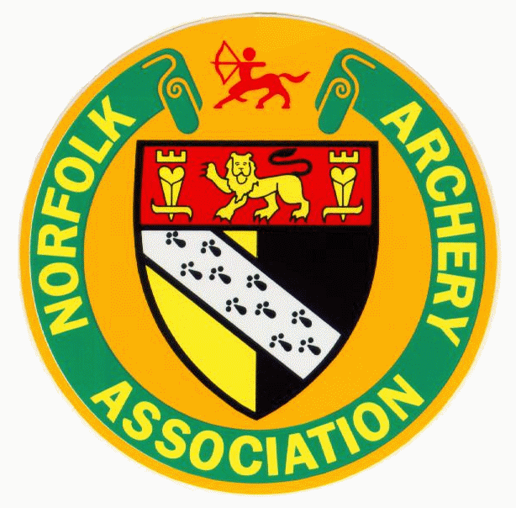
Norfolk Archery Association
Indoor Inter Club Postal League
Winter 2020 / 2021

We as a county will again be running a Postal League during this Indoor/Outdoor Season, this is to encourage some friendly inter club competition without the need to travel and to encourage archers and clubs to start to think about shooting and supporting other clubs within the county’s competitions.

Another of the aims of a inter club postal league is to find out who the in-form archers are and to help Sean Fox the County Team Manager when it comes to selecting archers for the county Squad to represent our county in competitions.

The competition for this winter will take the form of a Portsmouth postal league, in the same sort of variation as the BA Postal League which some of the county’s clubs already participate in.

For clubs that do not have facilities to accommodate a 20 yard range it is acceptable to shoot the longest distance possible on a 40cm face, please indicate if this is the case when email or posting results to Hayden.

Round - Portsmouth (Indoors or Outside)
Duration - League runs from October to March.
Straight league - All clubs submitting and ranked in team order for each bow style.
- Team placing based on all months.
- Individual placing based on top 4 scores.

Bow styles –
- Recurve (4 to count, minimum 1 from opposite sex)
- Compound (3 to count, minimum 1 from opposite sex)
- Longbow (3 to count, minimum 1 from opposite sex)
- Barebow (2 to count, minimum 1 from opposite sex)
- Junior mixed styles (4 to count, minimum 1 from opposite sex)

- All teams MUST contain members of the opposite sex as listed above. Failure to include an opposite sex member will have the highest score that month discounted for the team leagues.

Juniors Mixed team to have a handicap as follows. Any scores over 500 do not qualify for any adjustments.
Compound reduced by 5%
Barebow increased by 20% of Max - Score
Longbow increased by 40% of Max - Score
ie For BB if Max = 600 and scored 400 they get 400 + ((600-400) * 20%) = 400 + 40 = 440
All scores submitted will count, up to the maximum for that bow style. If less than the stated team size, then the number of scores submitted will count. All junior scores are to be submitted for the junior individual league.
All archers are expected to follow their counties normal submission criteria. All scores are submitted using the records@norfolkarchery.info address only to Hayden Cook, by your clubs record officer etc. No archers are to submit directly to Hayden.
ALL archers will compete in their own sex for the individual leagues.
For this year, scores submitted can be shot within the whole month (Due to many clubs only being able to shoot outside due to Coronavirus and the weather being a big factor). All scores must be submitted to the Postal scores address by the 6th of the following month.
Scores submitted must list Club, Archer, date shot, Score. All archers will automatically be included in the individual league. Medals will be awarded to top 3 Male and top 3 Female for each bow style (except Juniors where it will be top 3 junior gent and top 3 junior lady, irrespective of bow style).
All Scores to be submitted on the spread sheet / word document supplied by Hayden Cook. See the score submission sheet on Norfolk website
• If a junior submits scores for more than one bow style for the month then each score shall count.in the individual league but only one score will count in the team league.

All entries will automatically be used for the Southern Counties Postal League, which is entered by the County Records Officer, unless an archer wishes their score not to be used.

These rules are subject to change as required.

I can be contacted by email on records@norfolkarchery.info

Happy shooting

Hayden Cook
Records Officer

