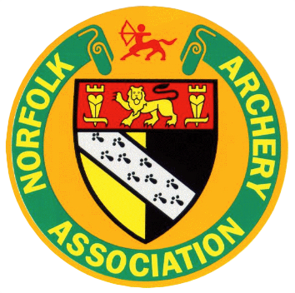 | Grant Application

Norfolk Archery Association will give a grant of £100 to any archer affiliated to the county who is on an Archery GB National Squad or selected to represent England or Great Britain at an international event.
Please supply proof of squad membership or international selection.
(Limited to one grant in a single calendar year)

Personal Details:
Title: | Forename: |  | Surname:
Address:
Town: |  | County: |  | Postcode:
Telephone: |  |  | Mobile:
DOB: |  |  | AGB No:
Email:

Claimant Signature (Parent if under 18): ……………………………………… Date: ….... / ….... / 20…...

Payment Method: Bank Transfer / Cheque (indicate preferred method of payment)

Bank Sort Code: ….. - ….. - ….. Account No.: ………………………….

Official use only

Cheque No. …………………………….. Date paid: ….... / ….... / 20…...

